
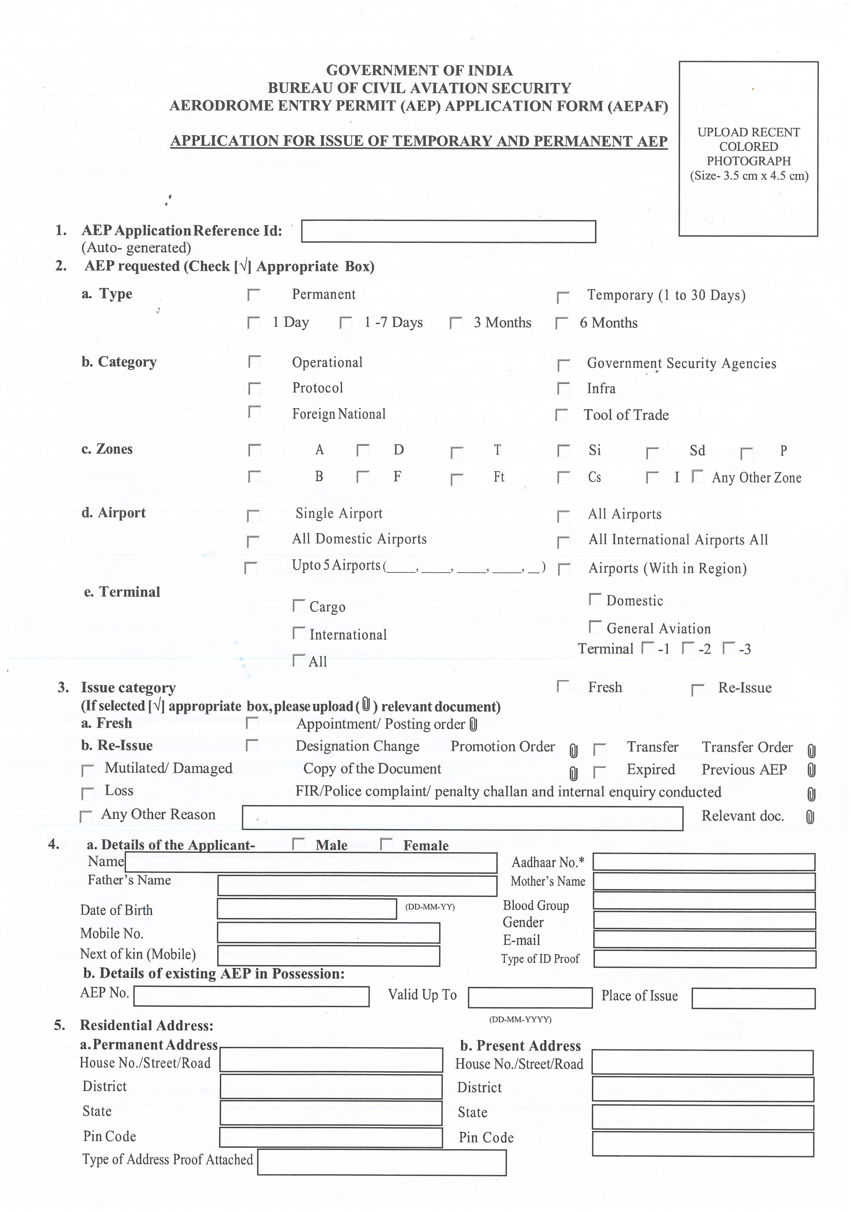
SAPHIA ISMAIL
9036488263
+91 9036488263

RGIA - HYD
MUSHTAQ MOHAMMED
501218
TELANGANA
RANGAREDDY

H.NO 20-170/1/1, RB NAGAR

ELECTRICITY BILL
400709

MAHARASHTRA

THANE/NEW MUMBAI

303/A,SEC 6, VISHAVARDAYA

12/SEP/2023
TP 88793
INDIAN PASSPORT
MUSHTAQ.ISMAIL@GOINDIGO.IN
MALE
A+
9772 0313 2804
27/09/1993
ISMAIL MOHAMMED
C A C S


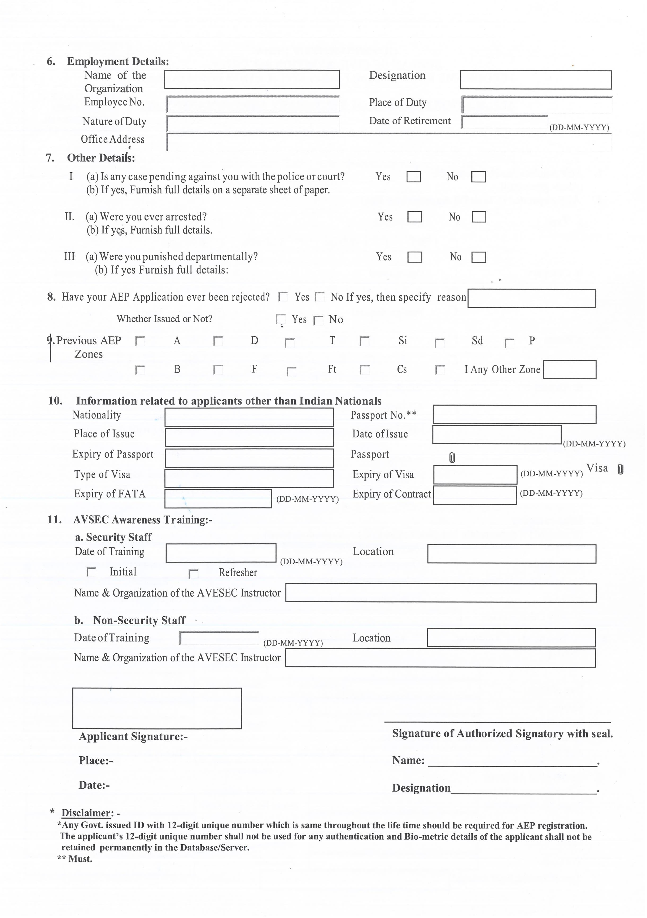
26/09/2053
ARCHANA DASH / INDIGO ASTI, BLR
BENGALURU
02/08/2023
AO-06, E- LEVEL OFFICES, PASSANGER TERMINAL BUILDING, RGIA, HYD, TELANGANA -500108.
SECURITY SERVICES
IGA 72835
EXECUTIVE - SECURITY
RGIA - HYD
RGIA - HYD

INTERGLOBE AVIATION LTD

